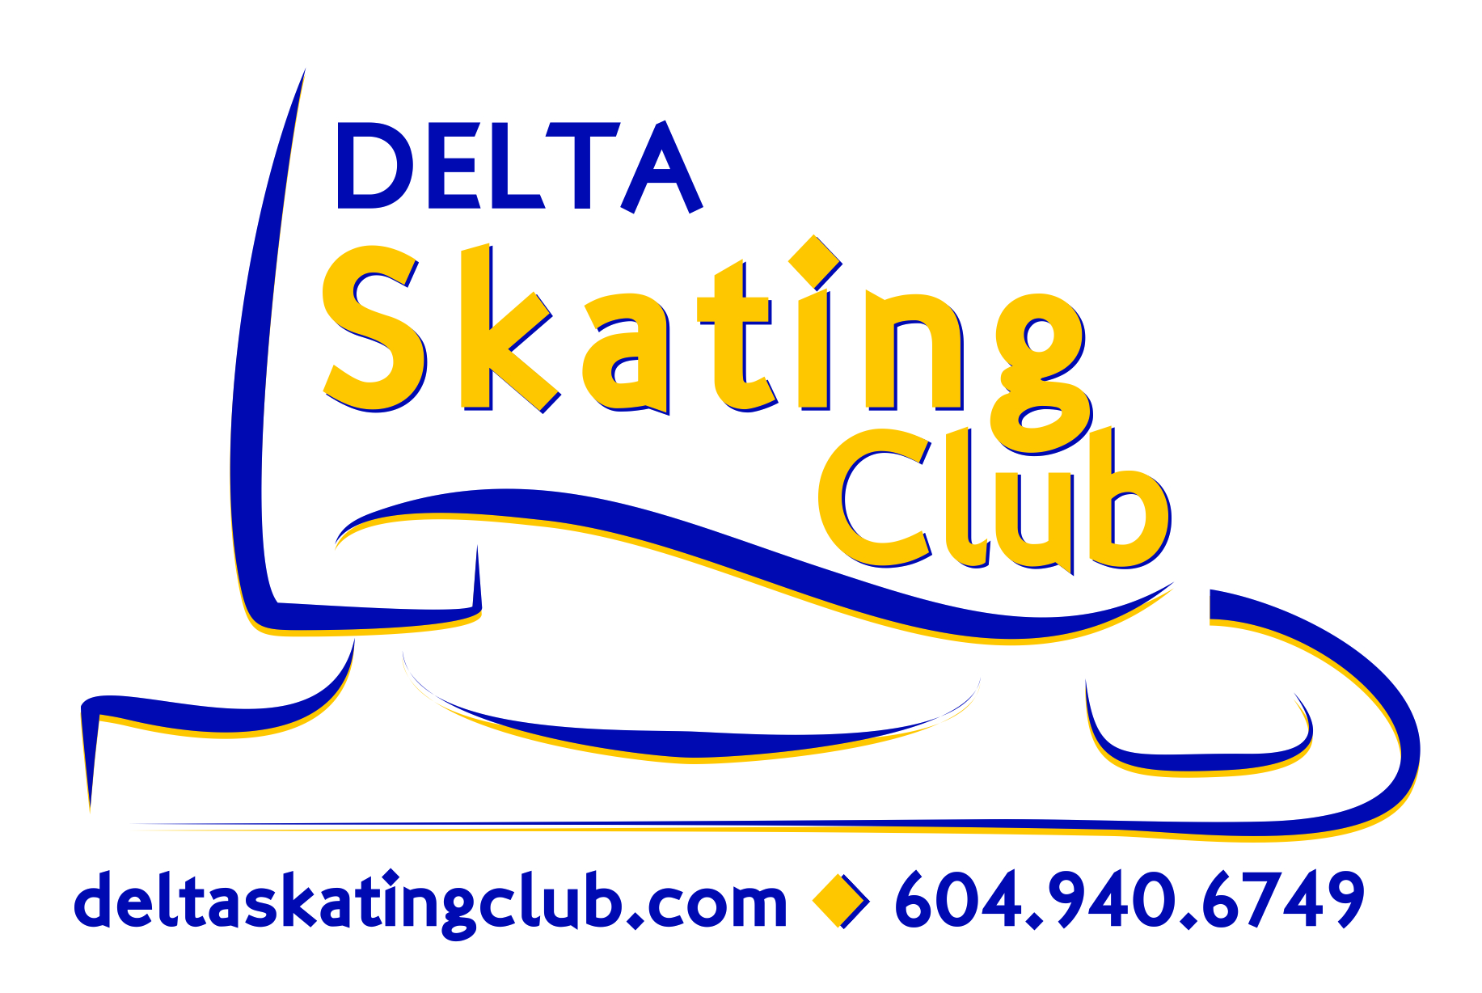
Delta Skating Club
Volunteer Form

Volunteers are integral to the running of Delta Skating Club and is important for a successful season. We encourage all of our parents to volunteer as volunteering not only allows you to meet the Board members, coaches and other parents, but it also gives you insight into the Club’s programs and development and helps keep our program costs low
.
We require each family with a Private Lesson skater to contribute 8 hours of volunteering from September 2015- March 2016

We require each family with a Skater enrolled in the Junior Development, Junior Figure Skating or in the Synchronized Skating Programto contribute 4 hours of volunteering from September 2015 – March 2016.
(Complete the number of hours based on the highest level group your child skates in.)

Volunteer opportunities will be emailed to you throughout the season.Each family must record completed volunteer hours on the “Volunteer Tracking Form”. When your minimum hours are complete, return the form to the Club Administrator and your postdated cheque will be shredded.

A $100 cheque dated March 15, 2016 is required on or before registration, and will be returned or destroyed if the complete requirement is fulfilled. If you have volunteered but have not completed the minimum number of hours by March 15, 2016 your cheque will be cashed.

If you do not want to Volunteer you may pay the $100 Volunteer Fee directly to the club. Date Cheque September 15, 2015.

Please fill out and return to the Delta Skating Club with guarantee cheque – One form per family !
- - - - - - - - - ✁- - - - - - - - - ✁- - - - - - - - - ✁- - - - - - - - - ✁- - - - - - - - - ✁- - - - - - - -
I have read and understood the above fundraising requirements.
Parents Name_____________________
Parent Signature ______________________Date _______________
Skater’s Name(s) _____________________________________________________________________ !
Program (of highest level skater) ______________

